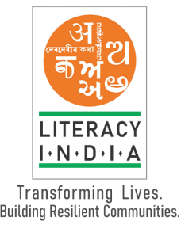

Literacy India Community College (LICC) 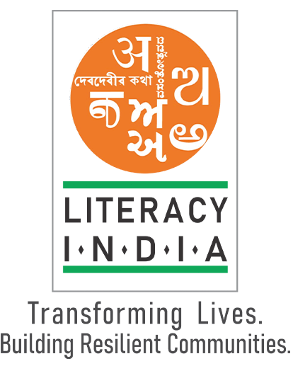

**Programs offered**

* Robotics/Tinkering
* Computer Hardware
* Mobile Repairing
* Cooking/Hospitality
* Beauty &Wellness
* Stitching & Cutting
* Electrical Troubleshooting
* Two –wheeler Repairing
* Mobile Journalism
* Computer Science
* Call Center /BPO
* Logistics
* Data Digitization
* Natural Farming Market Connect
* Banking

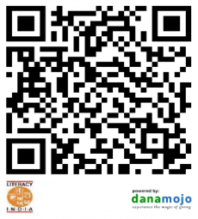

Contact no - **8588853380**

Session start from

January 2024

Limited seats

www.literacyindia.org

Register Now